7-2 Project Two
Joshua Kelly
Southern New Hampshire University
CS 340
Professor Cory Thoma, Ph.D.
4/19/2026

The purpose of this project was to develop a dashboard using the information stored at the Austin Animal Center database. In this specific case, we will focus on identifying those dogs that can be used for rescue training. The developed dashboard connects to the MongoDB database through my custom-created CRUD module in Python and allows users to filter data records based on certain criteria and display them interactively via a table. In addition, the dashboard provides an interface for displaying the filtered information as part of a geographical map and a second chart. The project requires me to include the Grazioso Salvare logo and my personal identification on the developed dashboard.
The dashboard was designed with the purpose of filtering the information by rescue categories presented in the specifications. There are four options for users – Water Rescue, Mountain or Wilderness Rescue, Disaster Rescue or Individual Tracking, and Reset. Filtering by one of these options triggers changes in the data table, in the geolocation map widget, and in the second chart widget as well. The Reset option sets all widgets back to the initial state with an unfiltered table of information. This task has been assigned to me as a client requirement; therefore, I needed to ensure that the dashboard was interactive and user-friendly.
The logic of filtering was defined based on the information from the Dashboard Specifications Document. In the case of filtering by Water Rescue, only Labrador Retrievers, Chesapeake Bay Retrievers, and Newfoundland-type dogs aged between 26 and 156 weeks and having Intact Females sex should be taken into account. In the case of Mountain or Wilderness Rescue, only German Shepherds, Alaskan Malamutes, Old English Sheepdogs, Siberian Huskies, and Rottweilers having the Intact Male sex and the same age should be taken into account. In the case of Disaster Rescue or Individual Tracking, only Doberman Pinschers, German Shepherds, Golden Retrievers, Bloodhounds, and Rottweilers having the Intact Male sex and aged 20 to 300 weeks should be considered. The decision was made to use the "age_upon_outcome_in_weeks" field because it seems to be the most convenient to use according to the project specifications.
I decided to use MongoDB for storing the records related to animal shelter because this system is based on document storage and uses Python to handle records, which can be easily done through a CRUD middleware module. Since the dashboard will filter the records based on breed, age, and sex, MongoDB seems to be an appropriate choice for the project. The CRUD middleware Python module is used to provide access to MongoDB from the dashboard to simplify the filtering operation. The previous CRUD Python module was specifically recommended in the project instructions to use MongoDB.
For developing the web application part of the project, I decided to use Dash because it provides the necessary functionality for creating filters, tables, and charts. I used Dash DataTable to create the data table, dash_leaflet to create the geolocation map, and Plotly Express to create a chart that shows the breed distribution. Finally, I used the pandas package to prepare the dataset for further work with the chart and table widgets by filtering MongoDB records in the proper way. As part of implementing branding requirements in accordance with the specification, I used the provided file with the Grazioso Salvare logo and added its path via base64-encoded link to SNHU.
To build this project, I first used the dashboard foundation from the previous milestones, particularly the unfiltered table of data and the geolocation map. Second, I imported my CRUD middleware module into ProjectTwoDashboard notebook and connected to MongoDB through the aacuser account. Then, I loaded unfiltered shelter data into a DataFrame for initializing the dashboard with unfiltered data by default. After completing this stage, I added the Grazioso Salvare logo and personalized information to comply with the branding requirements. At the next stage, I created the filters and implemented database filtering logic for each of the rescue types by specifying corresponding breed, sex, and age requirements from the Dashboard Specifications Document. After that, I connected these filters to the table, breed distribution chart, and map to ensure that all the widgets respond correspondingly.
The biggest challenge I faced during building the dashboard related to handling breed information in MongoDB records. In the majority of cases, dog breeds are specified as ‘mixbreeds’, which means that the records include information such as "German Shepherd Mix". In order to avoid missing such information, I decided to implement regex-based filtering to make it possible to catch more realistic values that can be found in the real-world shelter datasets. Another problem related to synchronization of widgets after selecting some filter. To overcome this challenge, I used the Dash callback system so that the table should be updated first and all charts could use this information. Also, I needed to make sure that the map would not crash when there is no selected row.
In order to reproduce this project, the user should download the files from the zip archive, including ProjectTwoDashboard.ipynb file, CRUD_Python_Module.py, and a logo file with the Grazioso Salvare logo. Also, the user should have access to the AAC MongoDB database through the aacuser account. All database entries should include the AAC Outcomes data set. Opening this project in Codio or JupyterLab will allow to start the dashboard, select any filter by clicking on a radio button, and observe how the data table, geolocation map, and breed distribution chart change their appearance in response to the selection. In the zip archive, the user can find the Project Two dashboard notebook and a CRDU module used for connecting to MongoDB. This README provides additional details about the dashboard development.
Below are some screenshots of the developed dashboard in the necessary states:
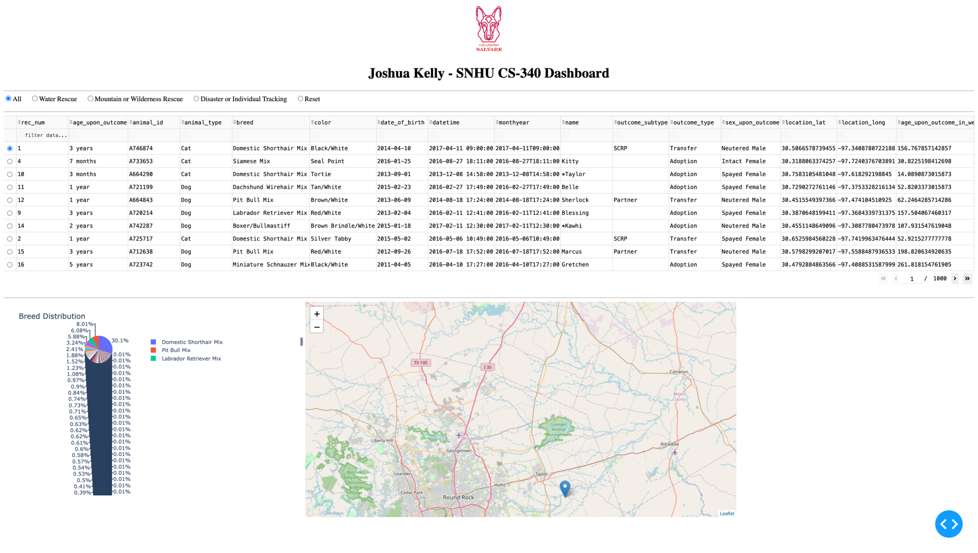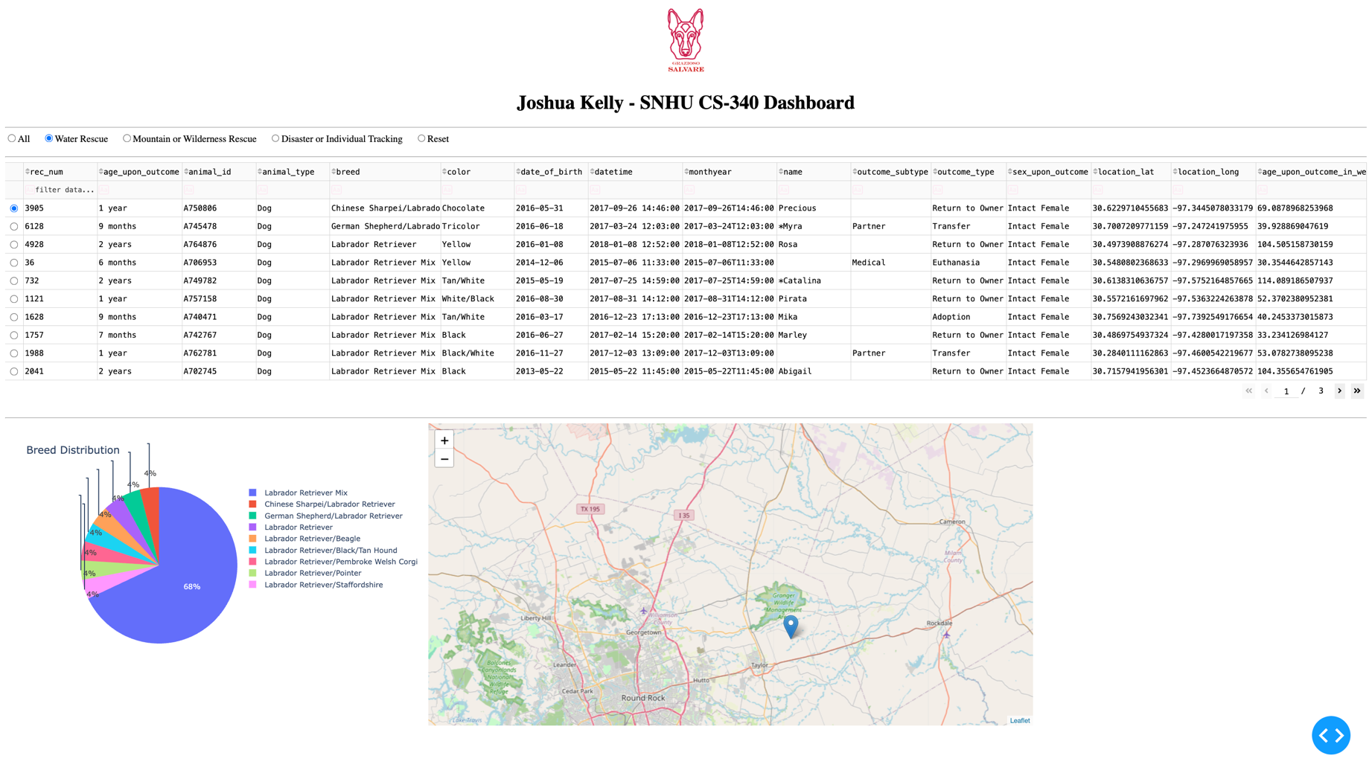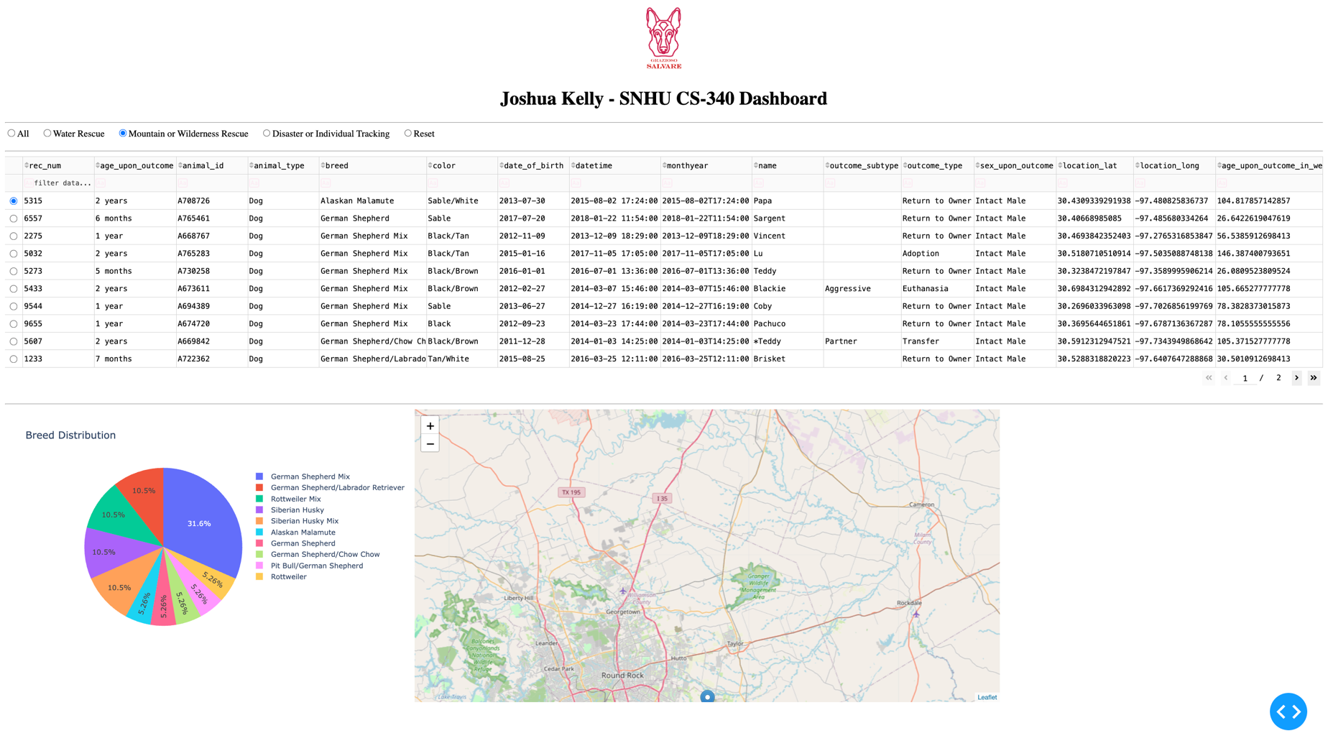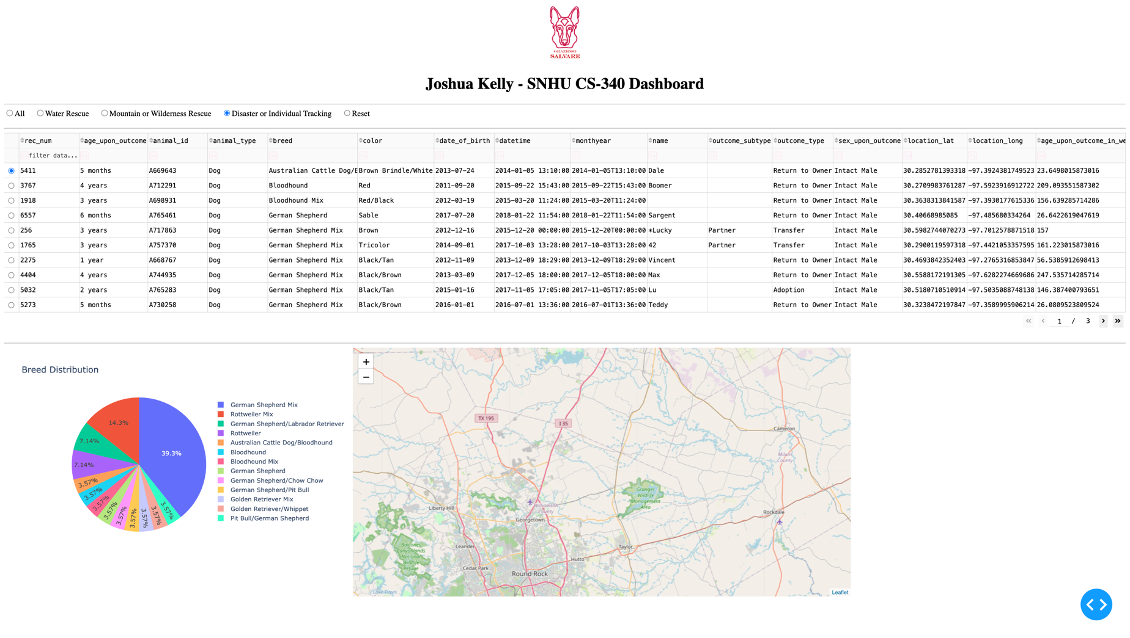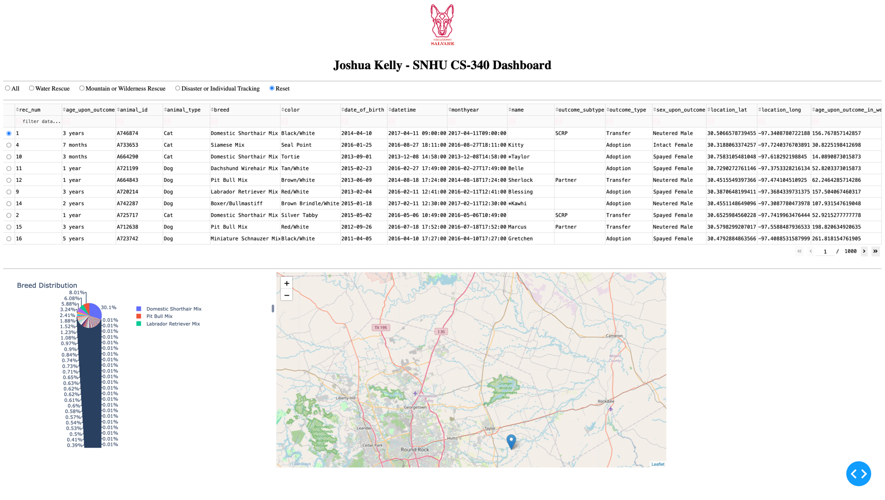

AI Use Acknowledgment: I used ChatGPT to assist me in understanding the requirements of the assignment and the development environment issues. The actual work was written by me.

